Embedded System Lab Manual
LAB EXPERIMENT NO. 1

Introduction to STM32CubeIDE and STM32F103C8T6 (Blue Pill)

Submitted To:
Sir Yasir
Submitter by:
Ahsan Basharat

Date of Submission:
30/06/2026

STM32CubeIDE Basics and STM32F103C8T6

Introduction
In this lab, we learned the basics of STM32CubeIDE and the STM32F103C8T6 (Blue Pill) development board. We studied the features, architecture, schematic diagram, pin configuration, and working principle of the Blue Pill. We also learned how to install and configure STM32CubeIDE, create a new project, write and compile code, build the project, upload the program to the microcontroller using ST-LINK, and debug the code. In addition, we explored the project structure, basic IDE tools, and the overall workflow.
Objectives
The key objectives of this lab are listed below:
- To understand the basic features and interface of STM32CubeIDE.
- To study the architecture and specifications of the STM32F103C8T6 (Blue Pill) development board.
- To learn how to create a new project in STM32CubeIDE.
- To write, compile, and build an embedded C/C++ program.
- To learn the basics of debugging and running programs in STM32CubeIDE.
- To understand the schematic diagram, pin configuration, and working of the Blue Pill board.


STM32CubeIDE
STM32CubeIDE is an advanced, free integrated development environment (IDE) created by STMicroelectronics specifically for programming and debugging STM32 microcontrollers and microprocessors. Built on the Eclipse/CDT framework, it supports Windows, macOS, and Linux platforms

Installing the CubeIDE
To download STM32CubeIDE, visit the official STMicroelectronics website and download the version that matches your operating system, such as Windows, Linux, or macOS. After the download is complete, run the installer and follow the on-screen instructions. Once the installation is finished, launch STM32CubeIDE, select a workspace folder, and the software will be ready for creating, compiling, uploading, and debugging STM32 projects.
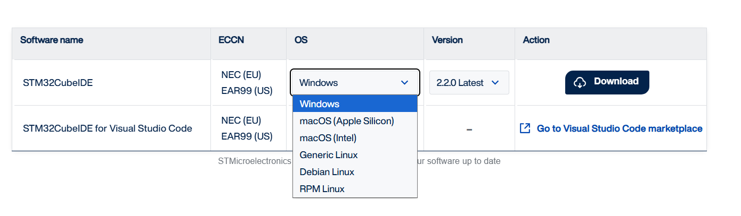
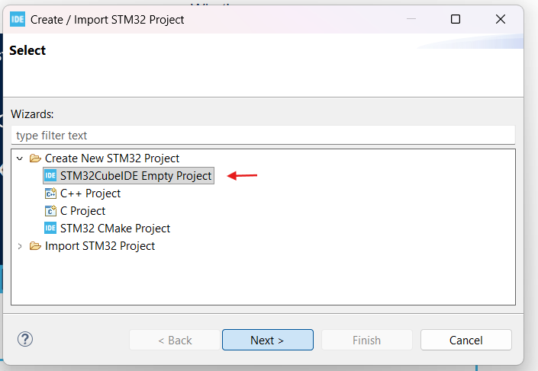
Making First Project
This section explains how to create your first project using STM32CubeIDE and introduces the basic workflow of the software. It also provides an overview of the project structure and explains the purpose of the important files and folders generated automatically, helping users understand how to write, build, run, and debug STM32 applications.
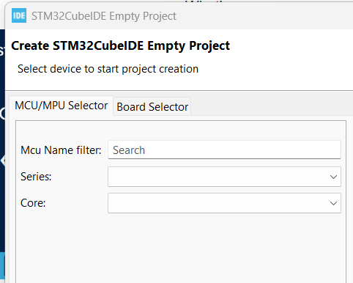
MCU/MPU Selection Window
The MCU Name Filter allows you to quickly find a specific STM32 microcontroller by typing its part number, such as STM32F103C8T6. The Series and Core options help narrow the list of available devices by filtering them according to the STM32 family and ARM processor core, making it easier to select the correct microcontroller for your project.

If .ioc is not Show on Folder Download the stm32CudeMX !!

STM32CudeMX
STM32CubeMX is a graphical software configuration tool developed by STMicroelectronics for STM32 microcontrollers. It allows developers to configure hardware settings, initialize peripherals, and automatically generate project code, reducing the need for manual programming.

STM32F103C8T6 Blue Pill
STM32F103C8T6, commonly known as the Blue Pill, is a low-cost, high-performance 32-bit ARM Cortex-M3 development board manufactured around the STM32F103C8T6 microcontroller from STMicroelectronics.
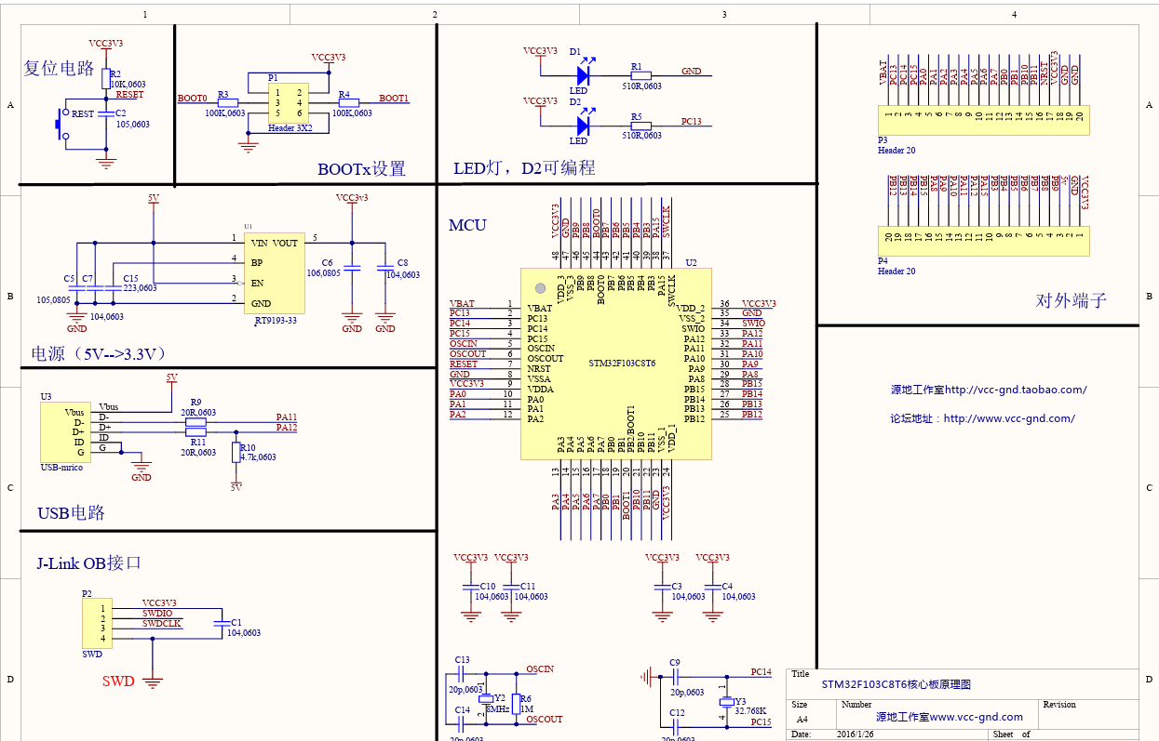
Schematic Diagram
Technical Specifications of STM32F103C8T6 (Blue Pill)
- Microcontroller: STM32F103C8T6
- Core: 32-bit ARM Cortex-M3
- Maximum Clock Speed: 72 MHz
- Flash Memory: 64 KB (many boards include 128 KB in practice)
- SRAM: 20 KB
- Operating Voltage: 3.3 V
- GPIO Pins: Up to 37 programmable I/O pins
- Analog Inputs: 10 channels with 12-bit ADC
- Communication Interfaces:
- HSI : 8MHz (Internal)
- LSI : 40KHz (Internal)
- HSE : 8MHz (external crystal)
- LSE : 32.768KHz (external crystal)
Pin Configuration of STM32F103C8T6
The STM32F103C8T6 (Blue Pill) development board provides 37 General-Purpose Input/Output (GPIO) pins, which are divided into three ports: GPIOA, GPIOB, and GPIOC. These pins can be configured for various functions, including digital input/output, analog input, communication interfaces, timer operations, and external interrupts. This flexibility allows the microcontroller to interface with a wide range of sensors, actuators, and external devices.

GPIO Port | Pins | No. of pins
GPIOA | PA0-PA15 | 16
GPIOB | PB0-PB15 | 16
GPIOC | PC13-PC15 | 3

Power and Control Pins
- 3.3V –>Supplies power to the microcontroller and external components.
- 5V –> External or USB power input.
- GND –> Ground reference.
- VBAT –> Backup power supply for the Real-Time Clock (RTC).
- NRST –> Resets the microcontroller.
- BOOT0 –> Selects the boot mode during startup.

Analog Input Pins:
The Blue Pill board provides 10 analog input channels connected to a 12-bit Analog-to-Digital Converter (ADC). These pins are:
- PA0 – PA7
- PB0 – PB1
These are Commonly used for reading analog sensors such as temperature sensors, potentiometers, and light sensors.
Special Function Pins
Some GPIO pins provide additional hardware functions:
- PC13 Connect to on-board user LED.
- PA13 SWDIO (Serial Wire Debug Data).
- PA14 SWCLK (Serial Wire Debug Clock).
These pins are mainly used for programming and debugging the microcontroller using an ST-Link programmer.

